

**Project Title**

**E-Learning Platform Phase-3**

**Group Members:**

|  |  |
| --- | --- |
| **Ishrat Fatima** | **22F-3616** |
| **Sabahat Jahangir** | **22F-3617** |

**DFD Level 0**

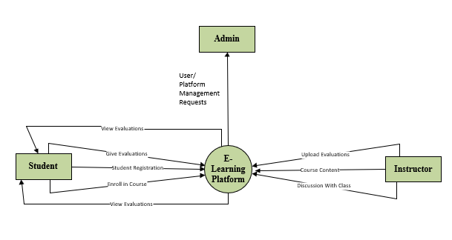

**DFD Level 1**

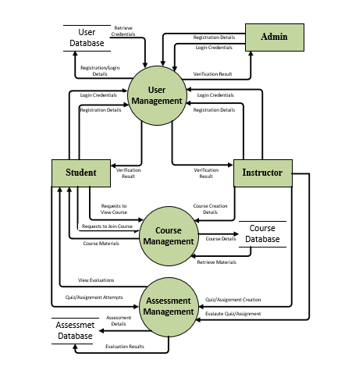

**DFD Level 2**

**For User Management**

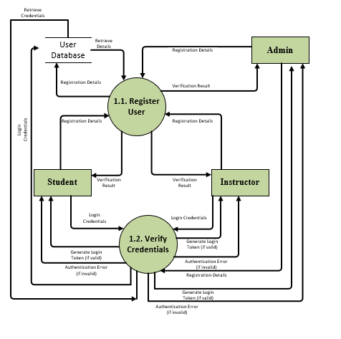

**For Course Management**

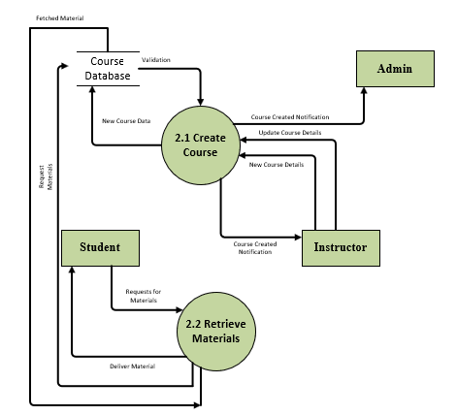

**For Assessment Management**

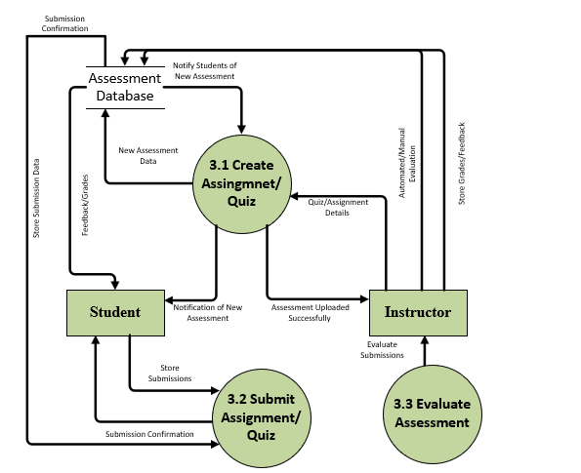

**Component Diagram**

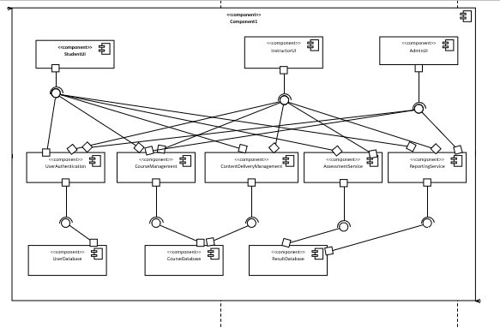

**Package Diagram**

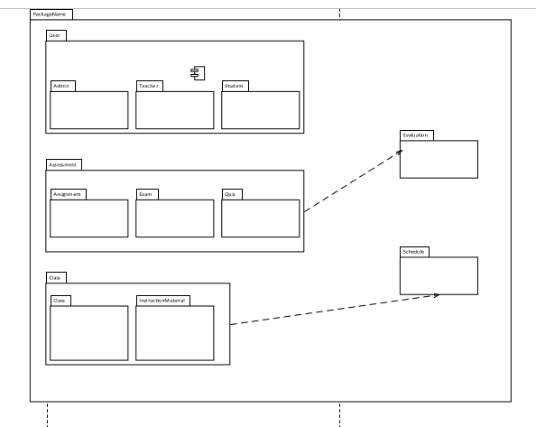

**Deployment Diagram**

